MODULE 4 – INTRODUCTION TO DBMS

LAB EXERCISES

5. ALTER Command
Lab 1.
Add a new column genre to the books table. Update the genre for all existing records.
Ans.
Add the genre column
1. ALTER TABLE books ADD genre varchar(255);
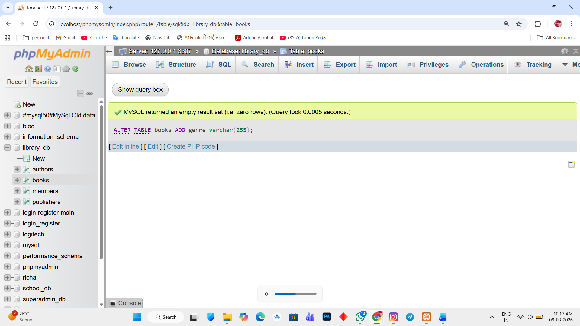

Update genre for existing records
2. UPDATE books SET genre = 'computer science' WHERE book_id = 1;
UPDATE books SET genre = 'Operating System' WHERE book_id = 2;
UPDATE books SET genre = 'Networking' WHERE book_id = 3;
UPDATE books SET genre = 'Data structures' WHERE book_id = 4;
UPDATE books SET genre = 'software engineering' WHERE book_id = 5;
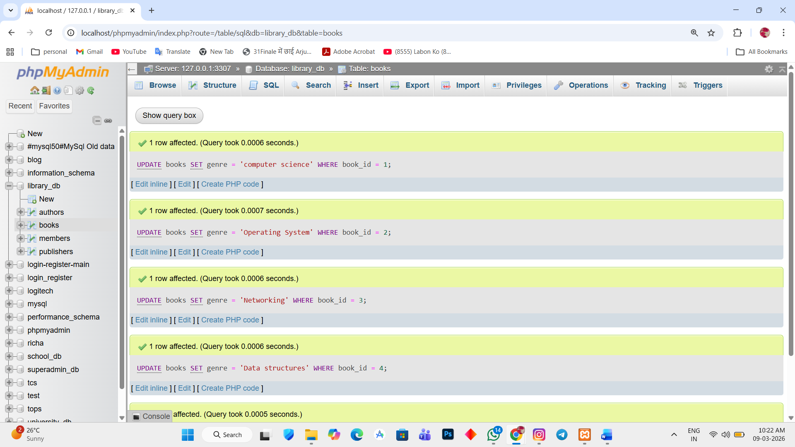

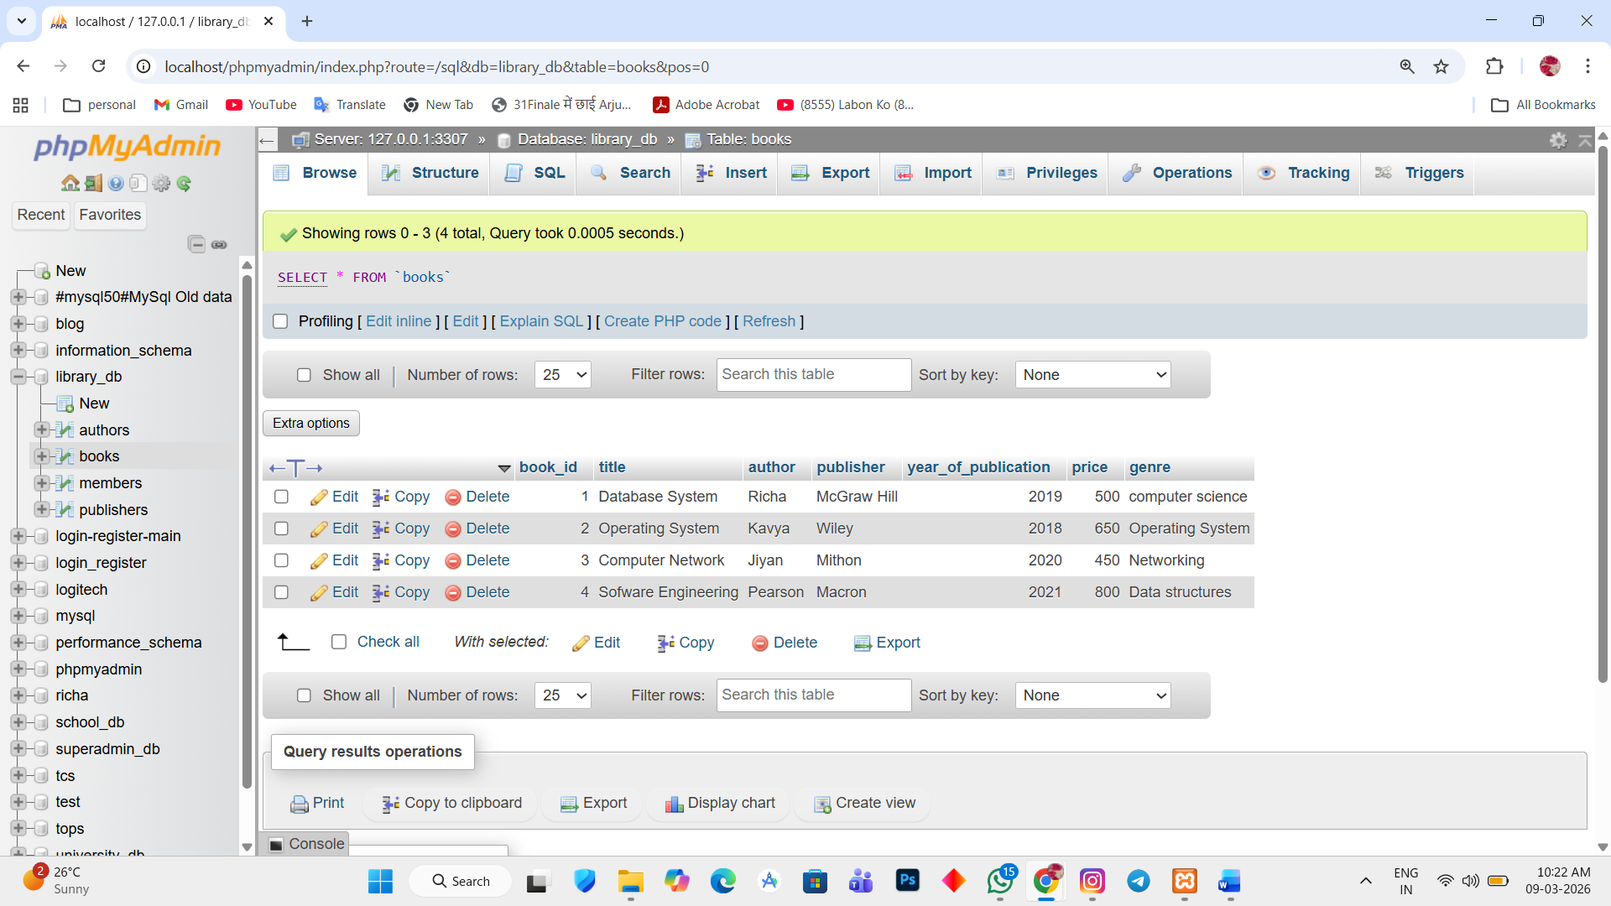

Lab 2.
Modify the members table to increase the length of the email column to 100 characters.
Ans.
1. ALTER TABLE members MODIFY email varchar(100);
